**Task Manager Application**

|  |  |
| --- | --- |
| Task Manager Application | Version 1.0 |
| Software Architecture & Design Document | Date: 28-072020 |
| Author | Gayaprasad Tiwari |

Table of Contents

**1.** **Introduction** 3

**2.** **Approach** 3

**3.** **Unit test** 4

**4.** **Services** 4

**5.** **Directives** 5

**6.** **Tools and libraries used** 5

**7.** **List of improvement** 5

**8.** **Setup and run** 5

# **Introduction**

This sample application involves in creation of dynamic task list and user can add, edit, delete, task on list also can drag drop list items from one to another and can drag drop whole list. 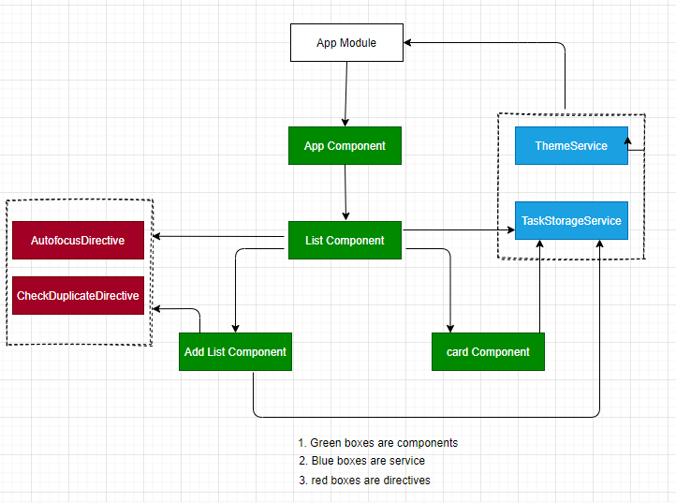

Figure 1: Architecture for Task Manager Application

# **Approach**

* App Component bootstrap by app module it contains title and radio buttons for theme implementation which is calls theme service to toggle theme and it has list component as child component
* List component renders the list and task and also has model to delete the list and tasks by using Task Storage Service which internally set data to local storage, And has to child component card component and add list component and **here you can edit task inline only by clicking it which also calls task storage service and also calls auto focus directive to focus input while editing task**.
* Card component adds the tasks to list by calling Task Storage Service also checks duplicate value by using **check duplicate directive**
* Add list component adds the list by calling Task Storage Service
* Task storage service has multiple methods to add delete and update task as well as lists.

# **Unit test**

Total number of unit test cases - 24

* [CheckDuplicateDirective](http://localhost:9876/?spec=CheckDuplicateDirective)
  + [should create an instance](http://localhost:9876/?spec=CheckDuplicateDirective%20should%20create%20an%20instance)
* [ListComponent](http://localhost:9876/?spec=ListComponent)
  + [should create](http://localhost:9876/?spec=ListComponent%20should%20create)
  + [SPEC HAS NO EXPECTATIONS should onModelClose method called](http://localhost:9876/?spec=ListComponent%20should%20onModelClose%20method%20called)
  + [should show 1 list item](http://localhost:9876/?spec=ListComponent%20should%20show%201%20list%20item)
* [CardComponent](http://localhost:9876/?spec=CardComponent)
  + [form invalid when empty](http://localhost:9876/?spec=CardComponent%20form%20invalid%20when%20empty)
  + [should create](http://localhost:9876/?spec=CardComponent%20should%20create)
  + [SPEC HAS NO EXPECTATIONS model shold be open](http://localhost:9876/?spec=CardComponent%20model%20shold%20be%20open)
  + [card field invalid when empty](http://localhost:9876/?spec=CardComponent%20card%20field%20invalid%20when%20empty)
* [AutofocusDirective](http://localhost:9876/?spec=AutofocusDirective)
  + [should create an instance](http://localhost:9876/?spec=AutofocusDirective%20should%20create%20an%20instance)
* [TaskStorageService](http://localhost:9876/?spec=TaskStorageService)
  + [should be created](http://localhost:9876/?spec=TaskStorageService%20should%20be%20created)
* [ThemeService](http://localhost:9876/?spec=ThemeService)
  + [should get available themes](http://localhost:9876/?spec=ThemeService%20should%20get%20available%20themes)
  + [should be created](http://localhost:9876/?spec=ThemeService%20should%20be%20created)
  + [should get active themes](http://localhost:9876/?spec=ThemeService%20should%20get%20active%20themes)
  + [should return dark theme](http://localhost:9876/?spec=ThemeService%20should%20return%20dark%20theme)
* [AddListComponent](http://localhost:9876/?spec=AddListComponent)
  + [SPEC HAS NO EXPECTATIONS should be edit method called](http://localhost:9876/?spec=AddListComponent%20should%20be%20edit%20%20method%20called)
  + [SPEC HAS NO EXPECTATIONS should be opem method called](http://localhost:9876/?spec=AddListComponent%20should%20be%20opem%20method%20called)
  + [should be addlist method called](http://localhost:9876/?spec=AddListComponent%20should%20be%20addlist%20method%20called)
  + [SPEC HAS NO EXPECTATIONS closeModel method should be called](http://localhost:9876/?spec=AddListComponent%20closeModel%20method%20should%20be%20called)
  + [should create](http://localhost:9876/?spec=AddListComponent%20should%20create)
* [AppComponent](http://localhost:9876/?spec=AppComponent)
  + [SPEC HAS NO EXPECTATIONS change theme to be called](http://localhost:9876/?spec=AppComponent%20change%20theme%20to%20be%20called)
  + [SPEC HAS NO EXPECTATIONS change theme to be called](http://localhost:9876/?spec=AppComponent%20change%20theme%20to%20be%20called)
  + [should render title](http://localhost:9876/?spec=AppComponent%20should%20render%20title)
  + [should create the app](http://localhost:9876/?spec=AppComponent%20should%20create%20the%20app)
  + [should have as title 'Task Manager'](http://localhost:9876/?spec=AppComponent%20should%20have%20as%20title%20%27Task%20Manager%27)

# **Services**

Below services used in Sample app

* theme Service (custom service created for theme)
* task storage service (to persist data)

# **Directives**

* check-duplicate directive
* auto-focus directive

# **Tools and libraries used**

* @angular/animations: "~9.1.9",
* @angular/cdk: "^10.1.0",
* @angular/common: "~9.1.9",
* @angular/compiler: "~9.1.9",
* @angular/core: "~9.1.9",
* @angular/forms: "~9.1.9",
* @angular/localize: "^9.1.12",
* @angular/material: "^10.1.0",
* @ng-bootstrap/ng-bootstrap: "^7.0.0",
* bootstrap: “^4.5.0",
* hammerjs: "^2.0.8",
* jquery: "^3.5.1",
* rxjs: "~6.5.4",

# **List of improvement**

* Add task creation date and time
* Add name of person who will do the task.
* Server-side implementation
* Log in page can be added for authentication

# **Setup and run**

* Install Node with npm
* Install angula cli
* git clone <https://github.com/gayaprasad-Tiwari/SampleApplication.git>
* cd SampleApplication
* npm install
* npm start